**TWO DIFFERENT OPTIONS TO SIGN IN CONSOLE**

1. **ROOT USER**
2. **IAM USER**

**STEP1:** SIGN IN TO ROOT USER

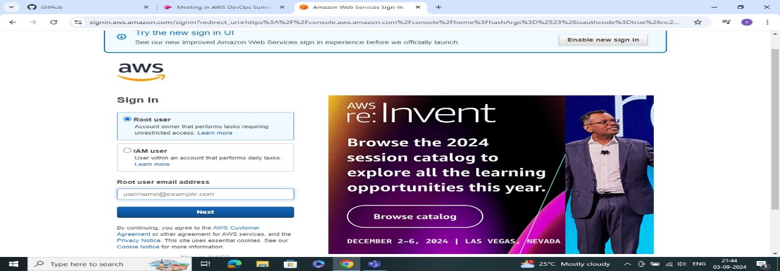

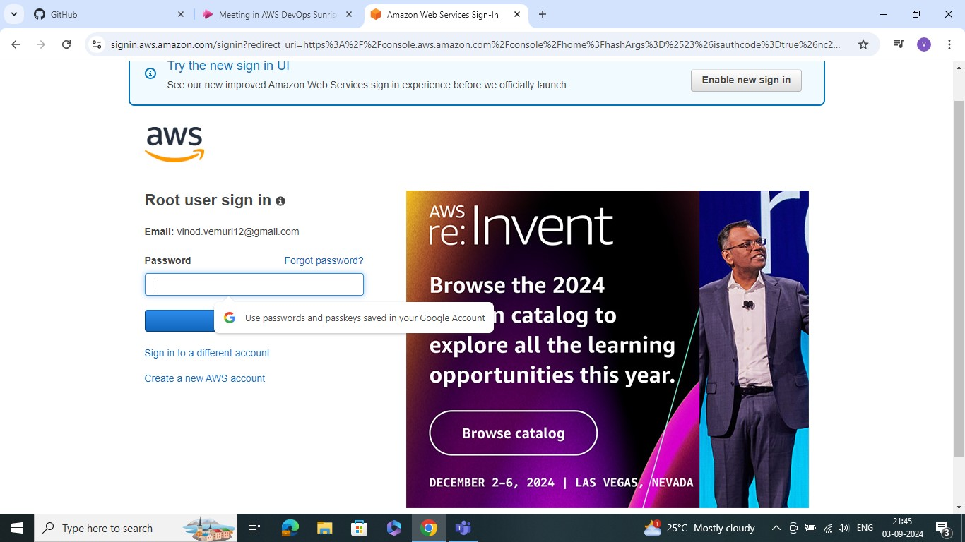

**STEP2:** AFTER GO TO ALL SERVERES AND SELECT TO THE SECURITY,IDENTITY AND COMPALIENCE AND SELECT THE IAM

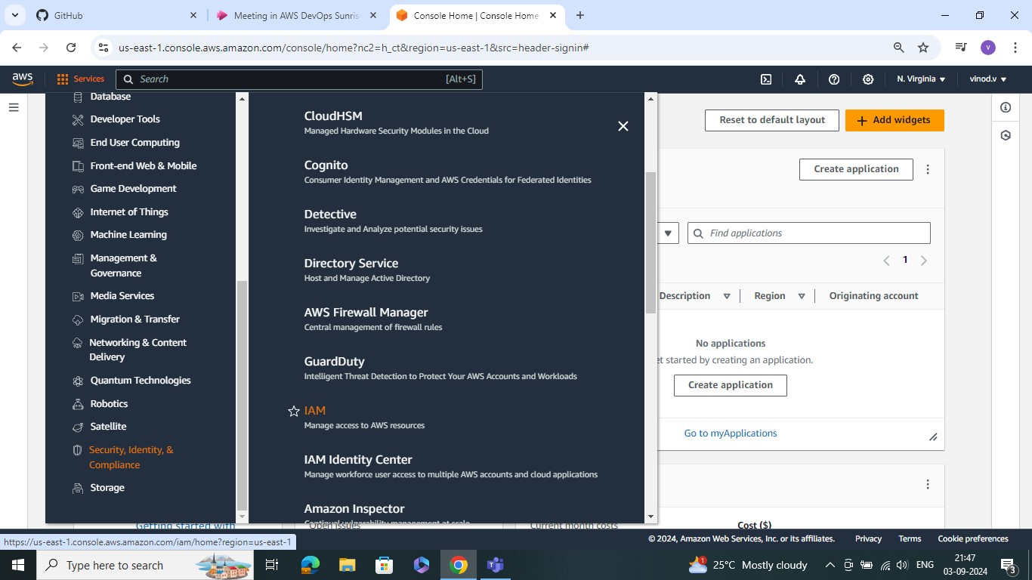

**STEP3:** AFETR GO TO THE IAM DASHBOARD

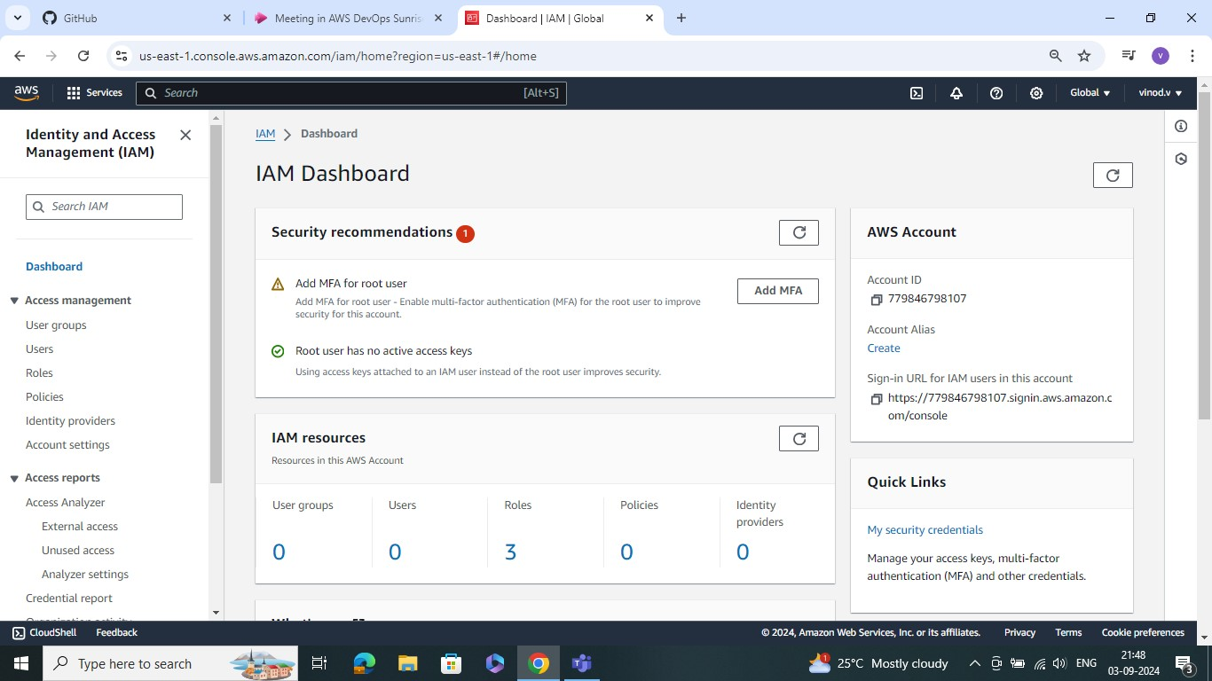

**STEP4:** AFTERE GO IAM DASHBOARD SELECT THE USER AND CREATE THE USER AND SPECIFY USER DETALIES

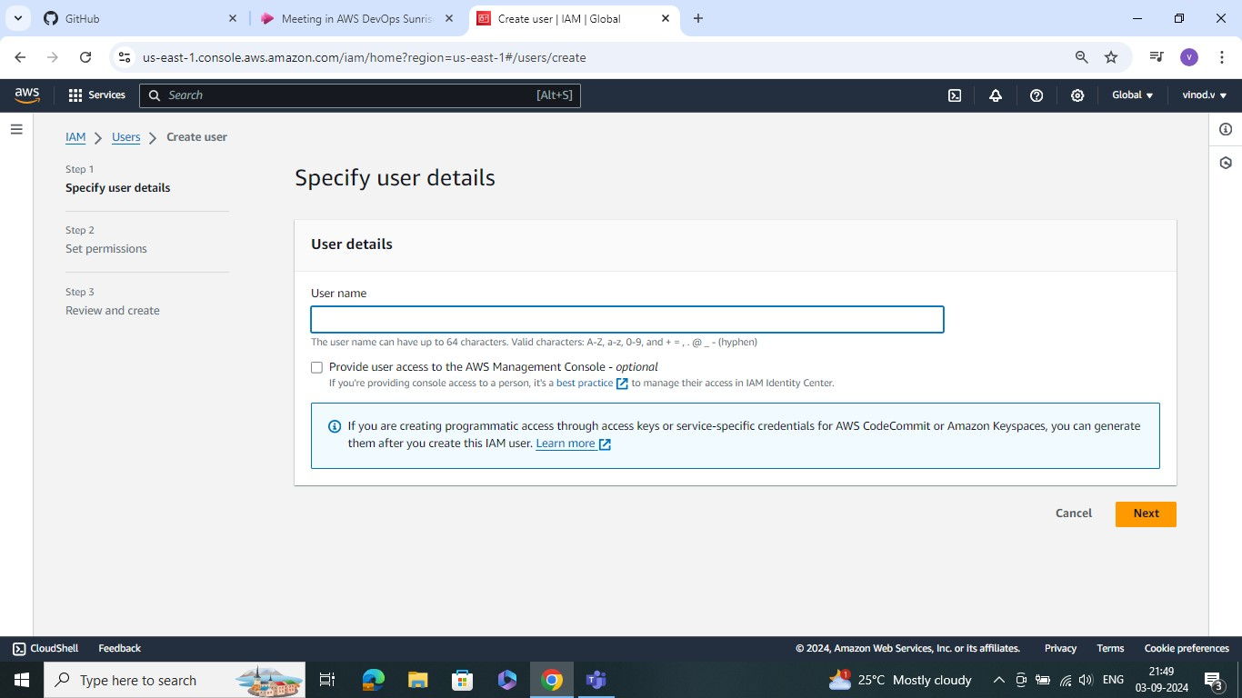

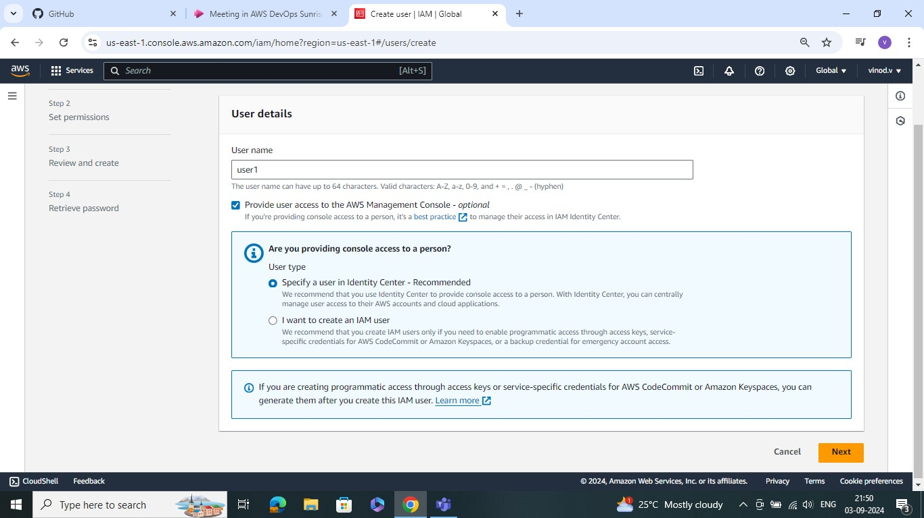

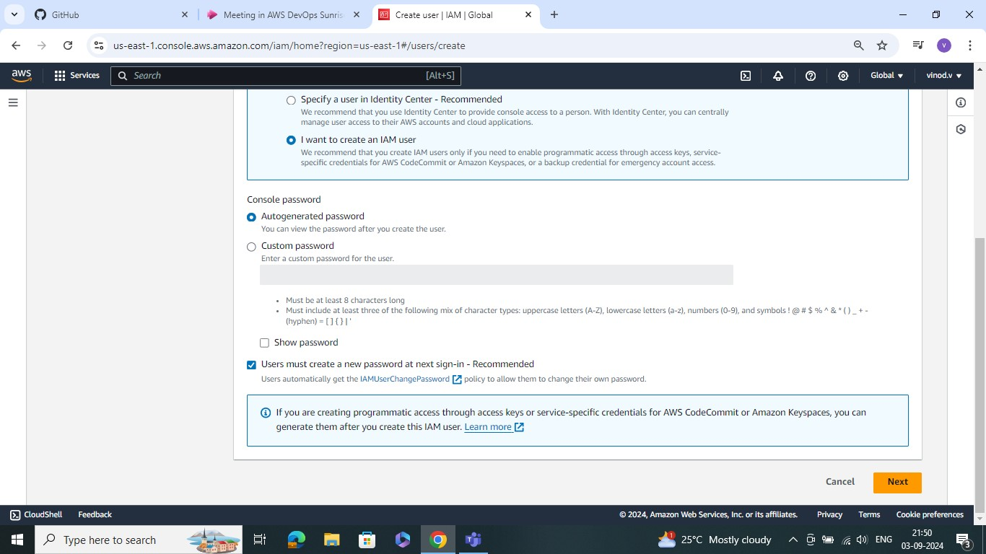

**STEP5:** SET PERMISIONS

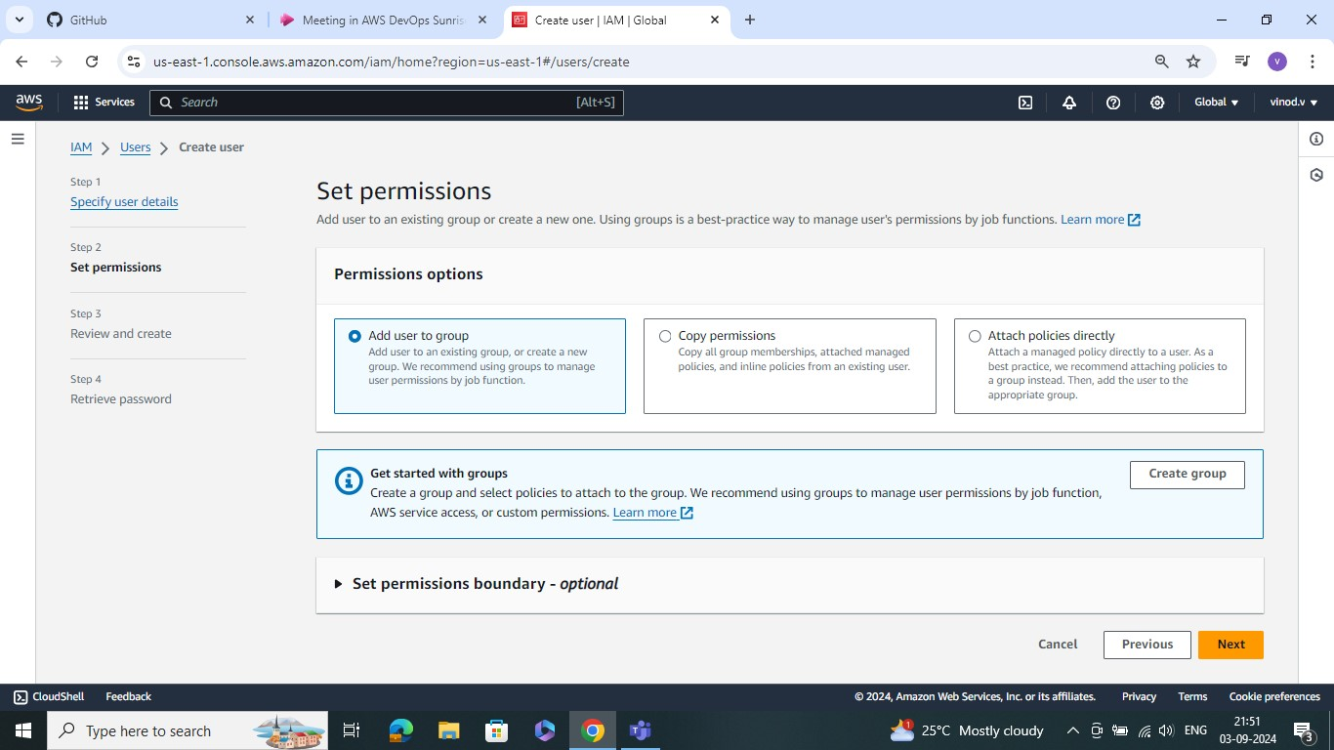

USER DETALIS

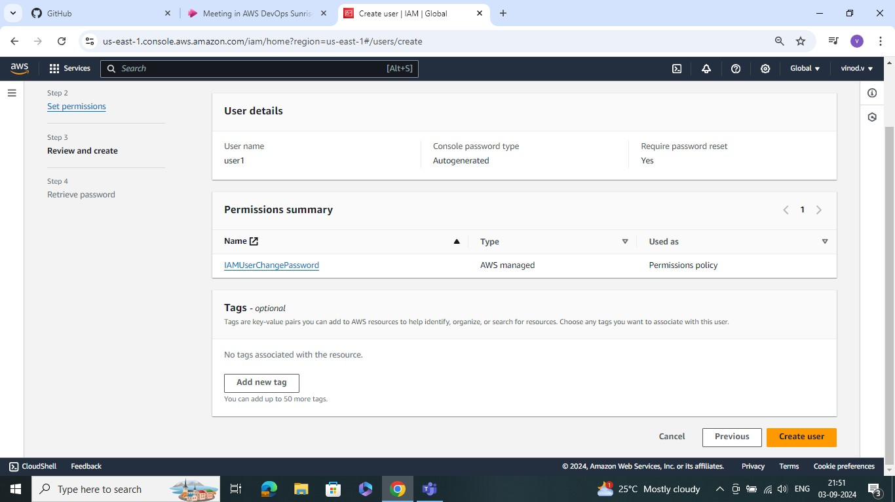

**STEP6:** RETRIVE PASSWORDS SIGN IN TO THE CONSOLE USER NAME AND PASSWORD ALL COPY AND PASTE TO THE WEBSERVER ANOTHER WINDOW

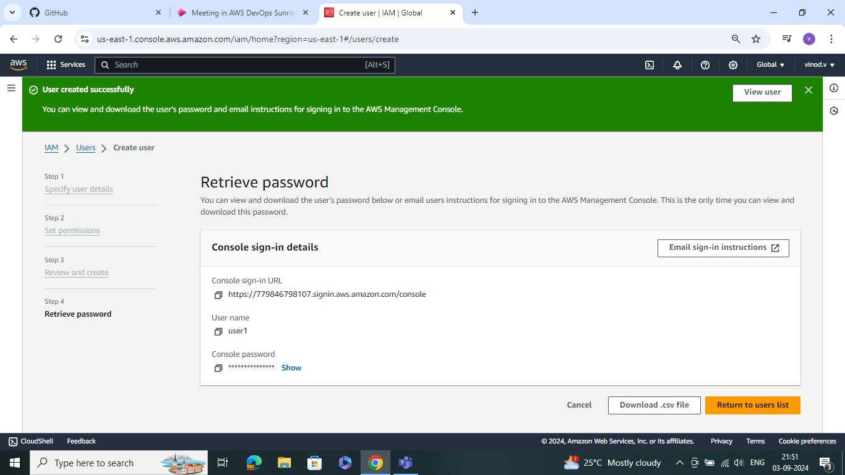

**STEP7:** SIGN IN IAM USER WITH ACCOUNT , USER NAME AND PASSWORD

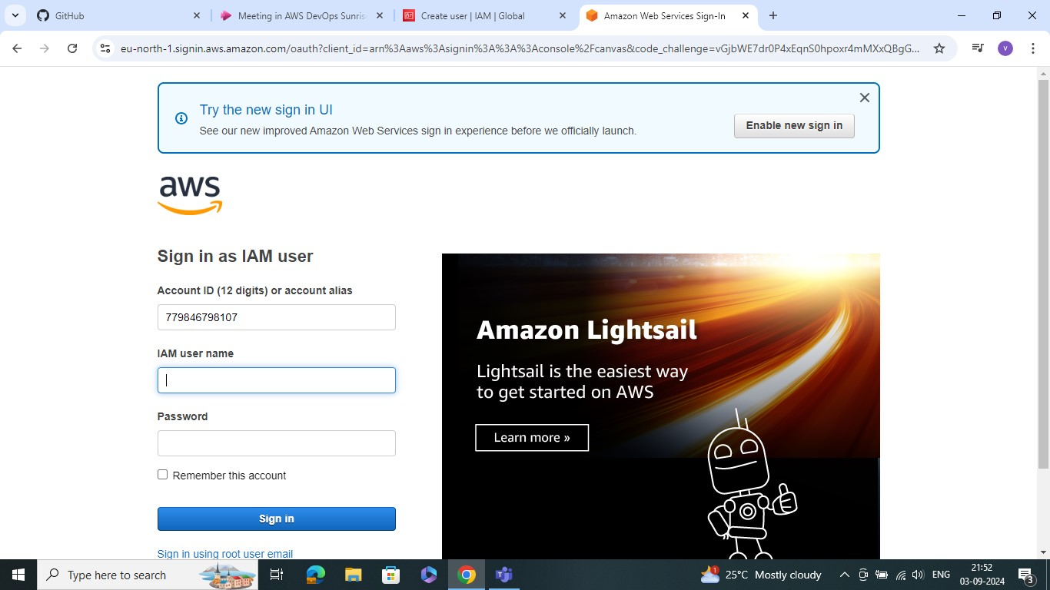

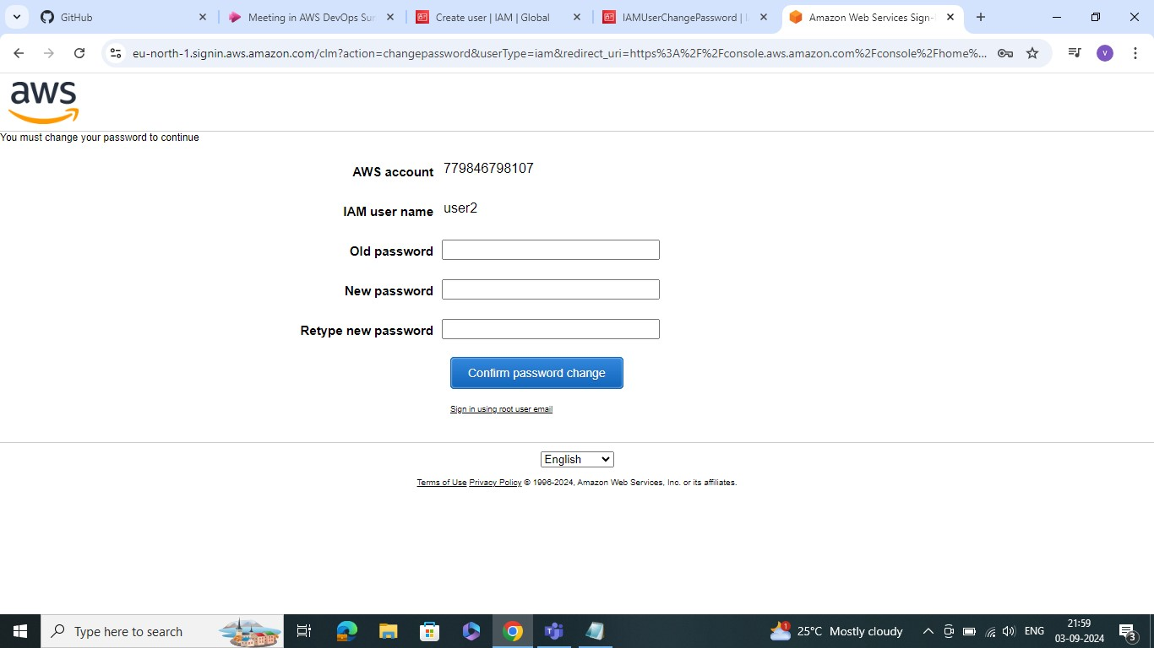

STEP8: AFTER CHEK TO THE CONSOLE HOME EC2 INSTANCE WAS ACCES DENIED

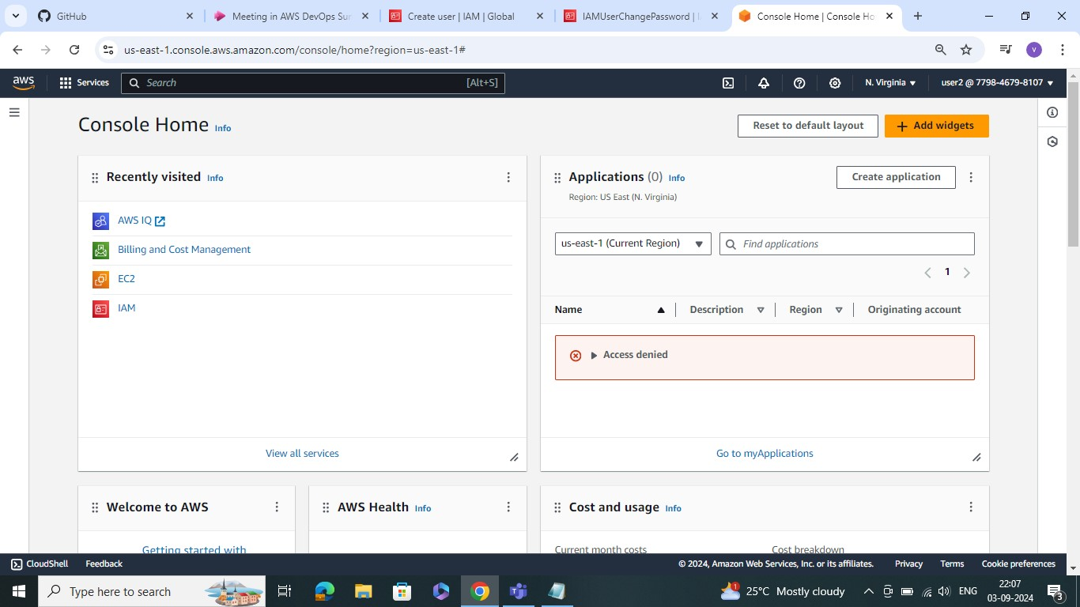

**STEP9:** GO TO THE EC2 DASHBOARD CHEK THE RESOURES ARE ACESS GIVEN ARE OR NOT IT SHOWS API ERROR

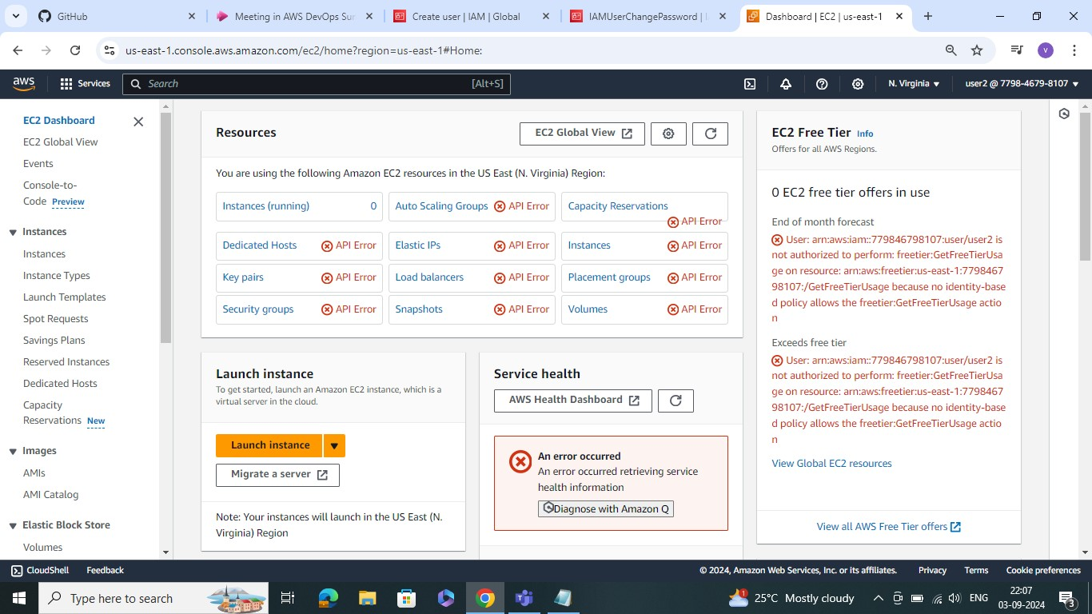

**STEP10:** GO IDENTITY AND ACCESS MANAGEMENT CHEK THE USER ACCESS ARE GIVN OR NOT

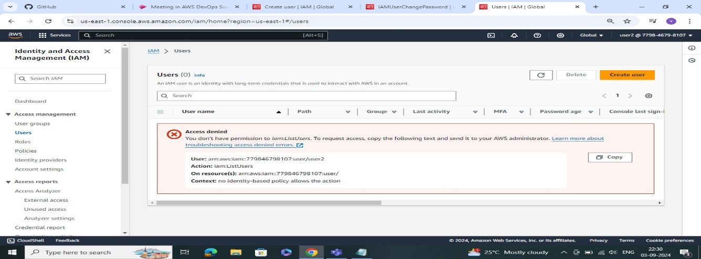

**STEP11:** SET THE PERMISSIONS GO TO THE ROOT USER AND GIVE THE PERMISION AND ADD

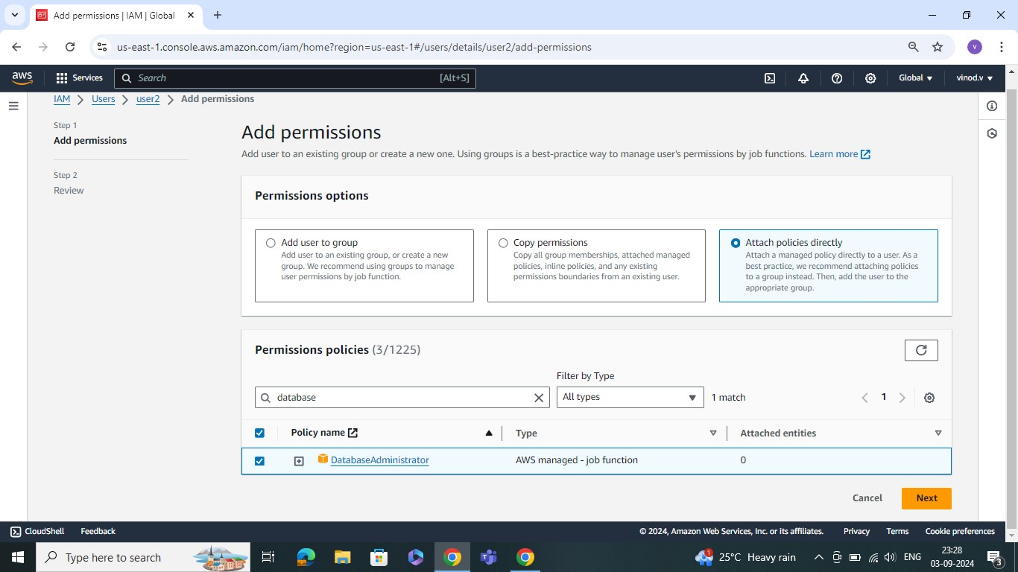

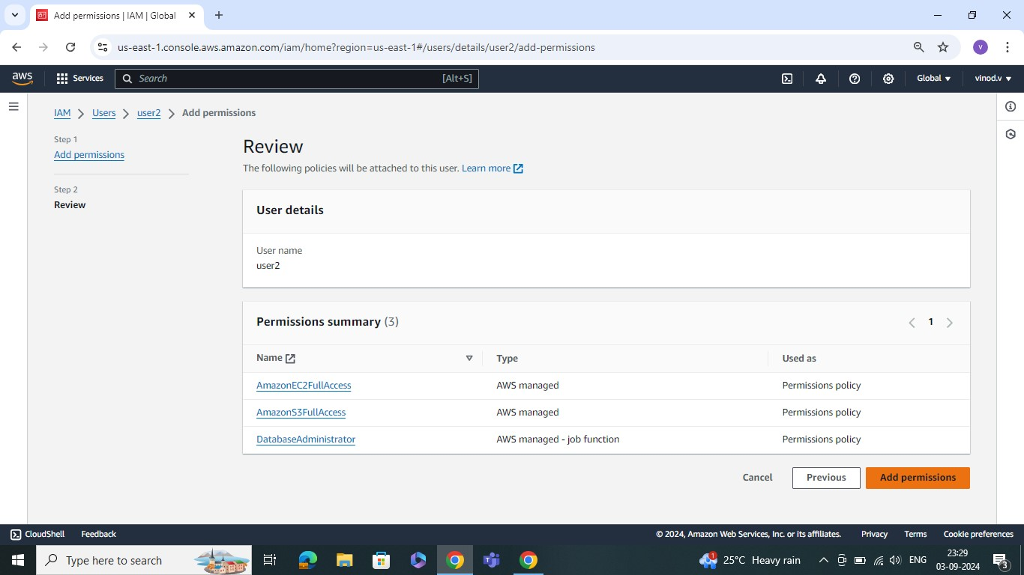

**STEP12:** CREATE THE USERGROUPS

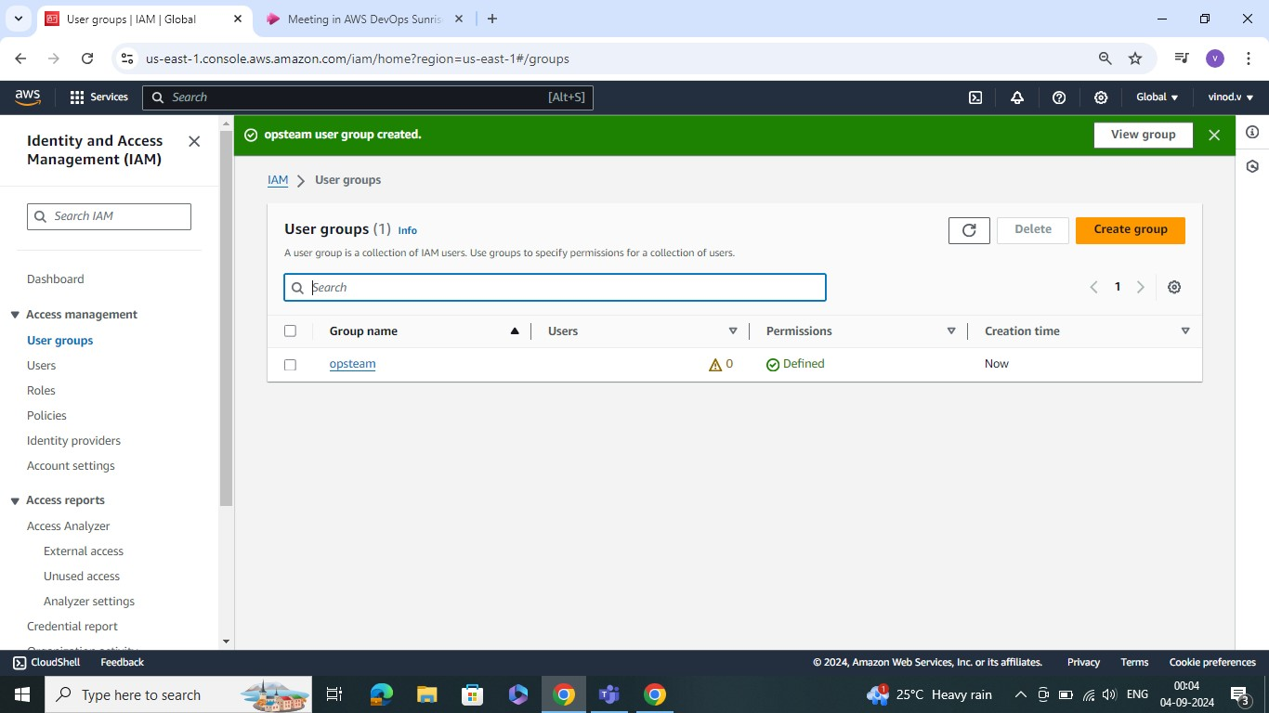

**STEP13:** ACCESS KEYS

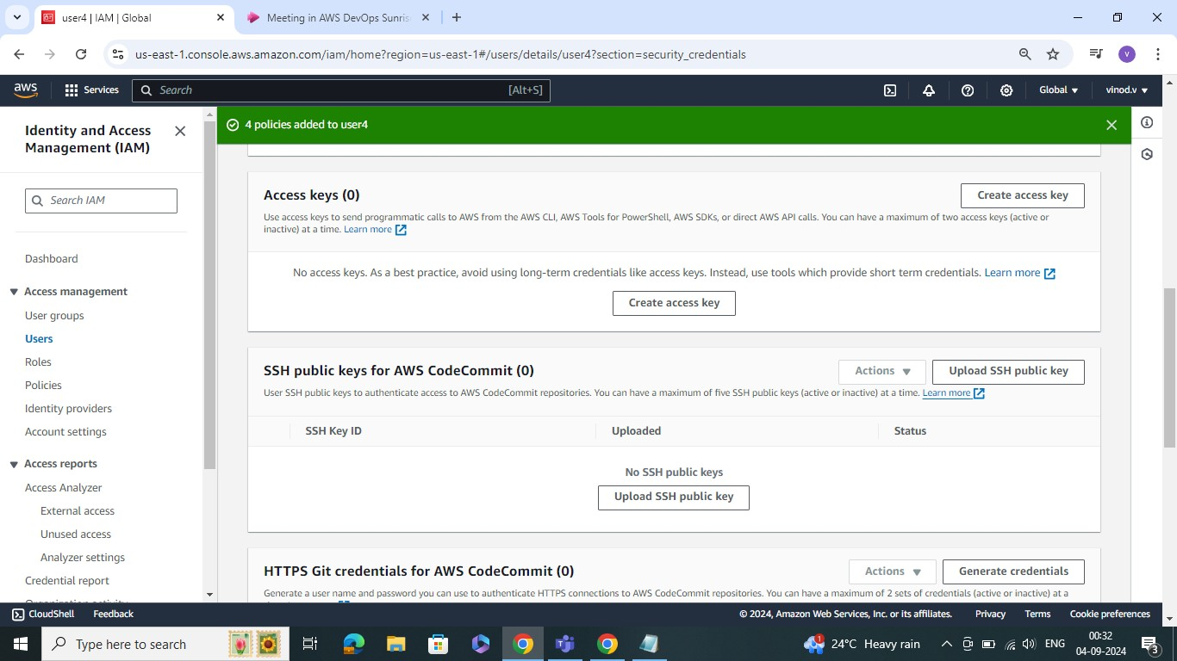

**STEP14:** RETRIEVE THE ACCESS KEYS

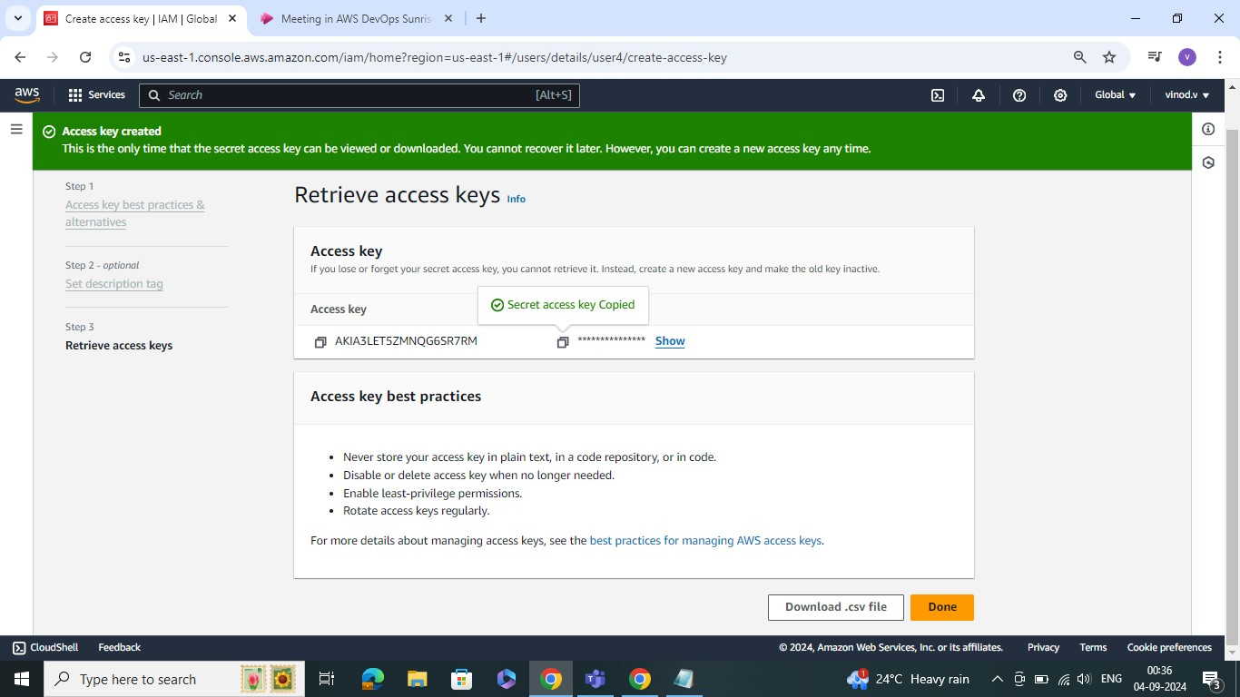

**STEP15**: GO TO THE INSTANCES AND LUNCH INSTANCES

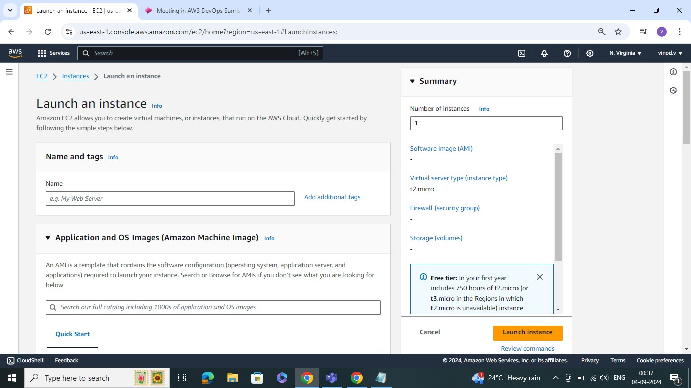

**STEP16:** CONNET TO THE COMMAND CLI

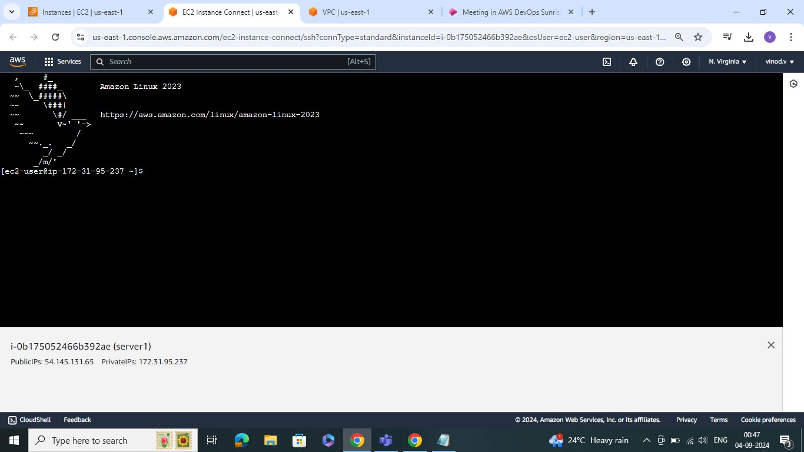

STEP17: COMMANDS RUN TO THE SERVER

